Multiple-choice section – choose the correct answer

Question 1 [7.1]

For the triangle shown, which of the following represents the ratio  for the angle *a*?

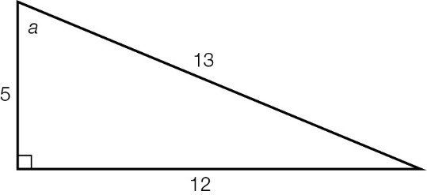

A B C D 

Question 2 [7.2]

If sin(θ) = , then the value of *x* in the diagram below is:

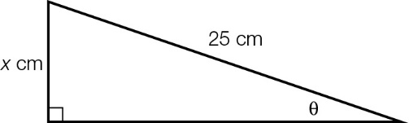

A 1 B 5 C 10 D 15

Question 3 [7.3]

Which equation can be used to find the value of *k* in the diagram?

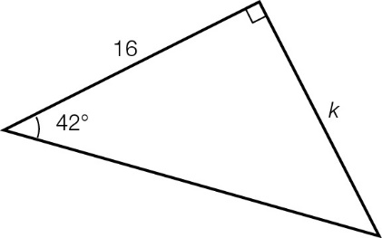

A sin(42°) =  B cos(42°) =  C tan(42°) =  D tan(42°) = 

Question 4 [7.4]

The value of θ can be found by using which of the following equations?

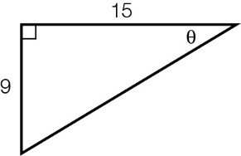

A cos(θ) =  B sin(θ) =  C tan(θ) =  D sin(θ) = 

Question 5 [7.5]

A 9.5 m tree casts a shadow across the ground. If the angle of elevation of the sun is 49°, the length of the shadow *s* is closest to:

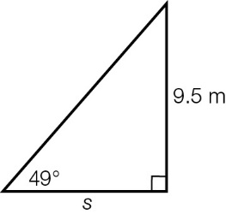

A 1.2 m B 6.2 m C 7.2 m D 8.3 m

Question 6 [7.5]

A bearing of 138°T, written as a compass bearing, is:

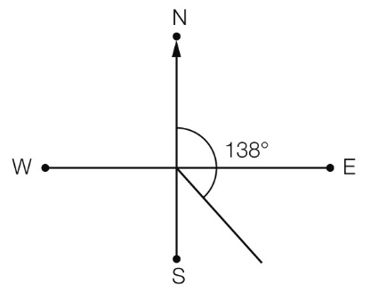

A N48°E **B** S48°E **C** S42°E **D** N42°W

Multiple-choice results: \_\_\_ / 6

Short answer section

Question 7 3 marks [7.5]

The bottom of the slide is 3.2 m away from the base of the supporting pole. If , find the length of the slide.

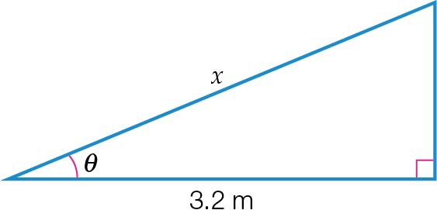

Question 8 3 marks [7.5]

A motorcyclist travels 9 km north, then 7 km east. Find the motorcyclist’s bearing from the starting point to the nearest degree.

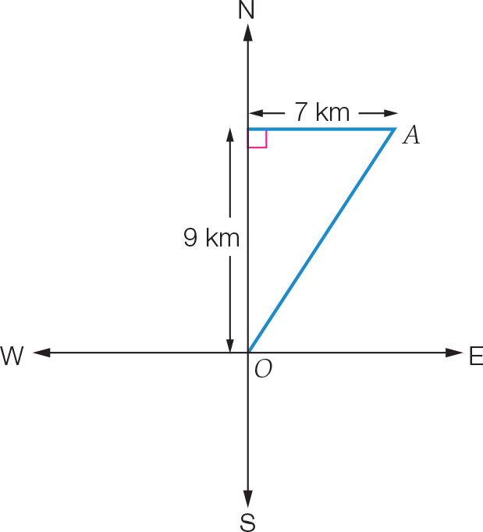

Question 9 3 marks [7.1]

A right-angled triangle has sides of length 7 cm, 24 cm and 25 cm.

**(a)** Which of these sides would be the hypotenuse?

**(b)** Draw a diagram of the triangle with the vertices labelled *A*, *B* and *C* and the right angle at *B*. Mark the side lengths on the diagram.

Question 10 4 marks [7.3]

Find the value of the unknown lengths, correct to 1 decimal place.

|  |  |
| --- | --- |
| **(a)**  ACPM9_PR_7_09tf | **(b)**  ACPM9_PR_7_10tf |

Question 11 4 marks [7.4]

Find the value of θ, correct to the nearest degree, in each of the following.

|  |  |
| --- | --- |
| **(a)**  ACPM9_PR_7_11tf | **(b)**  ACPM9_PR_7_12tf |

Question 12 2 marks [7.3]

A supporting wire is attached 6.3 m up a pole. If the wire makes an angle of 52° with the ground, find the distance from the pole to the wire. Give your answer correct to 1 decimal place.

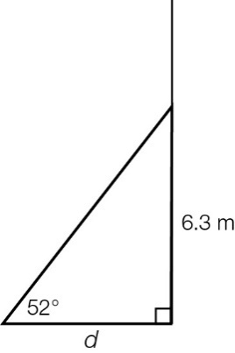

Question 13 3 marks [7.5]

The angle of elevation to the top of a mobile phone tower from a point 150 m from the base is 38°.

**(a)** Draw a sketch of the information provided.

**(b)** Find the height of the tower, correct to 1 decimal place.

Short answer results: \_\_\_ / 22

Extended answer section

Question 14 6 marks [7.5]

An 11 m long ladder is leaning against a building inclined at an angle of 62° with the ground.

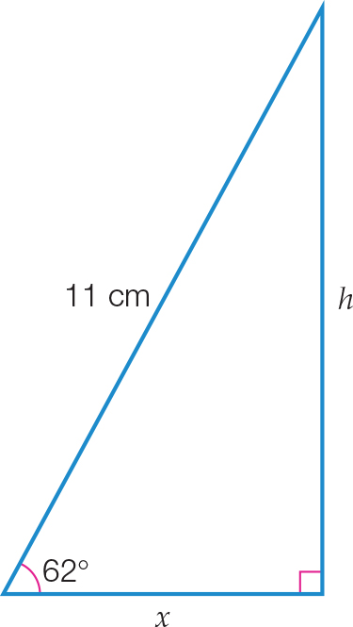

**(a)** At what height does the ladder touch the building, correct to 2 decimal places?

**(b)** What is the distance between the foot of the ladder and the building, correct to 2 decimal places?

**(c)** Find the angle the ladder is making with the building, to the nearest degree.

Question 15 6 marks [7.5]

A hiker begins walking from a car park at point *P*. He walks 3 km due east, then turns and walks 4.5 km due south to point *Q*.

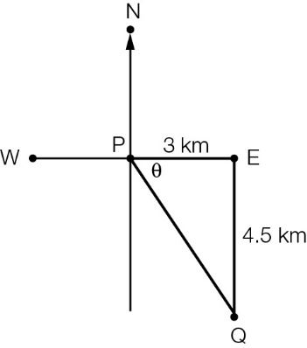

**(a)** **(i)** Find the value of the angle θ, correct to the nearest degree.

**(ii)** use your answer to **(i)** to find the true bearing of *Q* from *P*.

**(b)** **(i)** If the hiker walks from *Q* directly back to his starting point *P*, how far will he walk?   
 State your answer correct to 1 decimal place.

**(ii)** Find the total distance he will have walked after returning directly back to point *P*.

Extended answer results: \_\_\_ / 12

TOTAL test results: \_\_\_ / 40